- Coverage vs Hallucination Rate Graph Interpretation
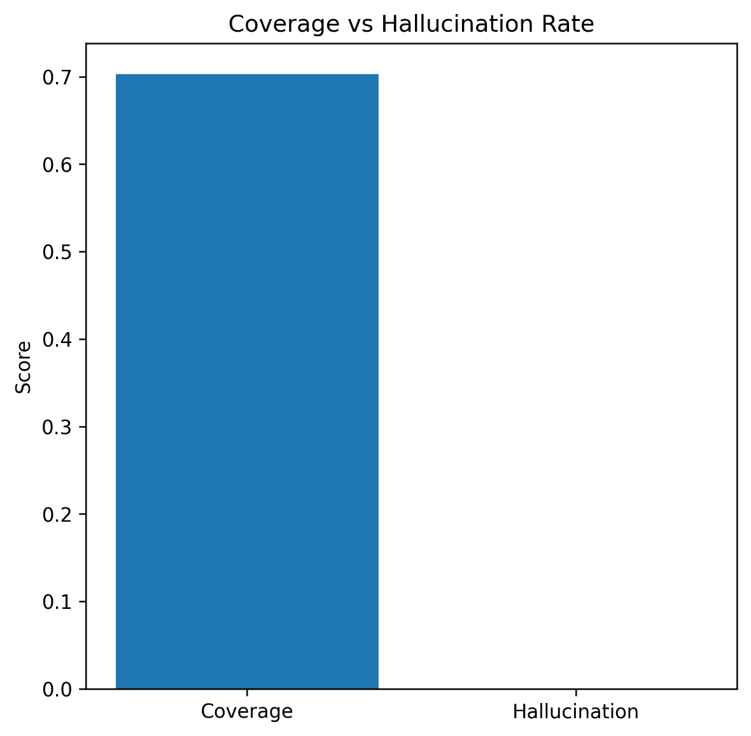
The “Coverage vs Hallucination Rate” graph demonstrates the effectiveness of the proposed Graph-RAG verification framework in retrieving meaningful evidence while minimizing unsupported reasoning. The graph shows that the system achieved a relatively high coverage score of approximately 0.70, indicating that the model was able to retrieve and verify evidence for nearly 70% of the processed medical claims. This reflects the capability of the knowledge graph to provide substantial semantic grounding during the verification process. In contrast, the hallucination rate is extremely close to zero, which indicates that the framework rarely generated unsupported or fabricated conclusions without evidence from the knowledge graph. This result confirms that integrating structured semantic relationships into the retrieval and reasoning process significantly improves reliability and reduces the common hallucination problem observed in conventional LLM-based verification systems. Overall, the graph validates that the Graph-RAG approach enhances factual consistency while maintaining strong evidence retrieval performance in health fake news verification.
- Medical Entity Frequency Graph Interpretation
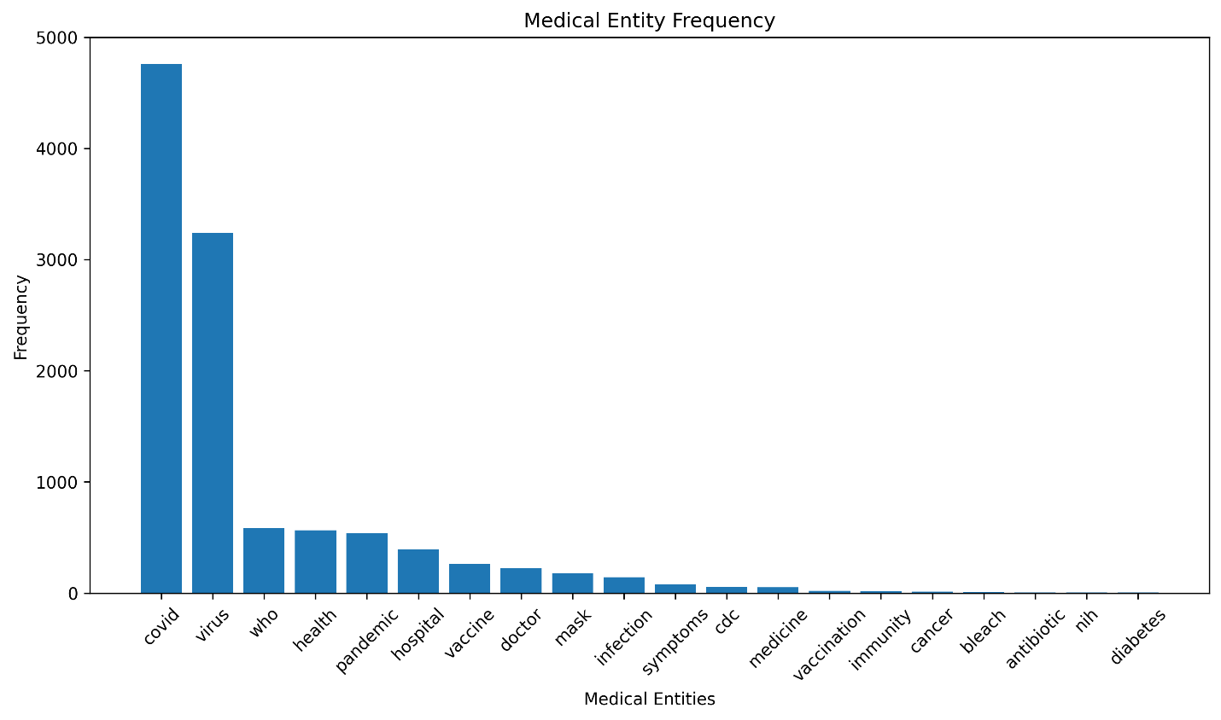
The “Medical Entity Frequency” graph illustrates the distribution and occurrence frequency of extracted medical entities within the health fake news dataset. The graph reveals that the entities “covid” and “virus” have the highest frequencies, significantly exceeding all other entities, which indicates that the dataset is heavily centered around COVID-19-related misinformation and discussions. Other frequently occurring entities such as “who,” “health,” “pandemic,” and “hospital” demonstrate that institutional healthcare information and public health topics play a major role in the analyzed claims. Medium-frequency entities including “vaccine,” “doctor,” “mask,” and “infection” further confirm that preventive healthcare measures and treatment-related information are strongly represented in the dataset. In contrast, entities such as “bleach,” “antibiotic,” “nih,” and “diabetes” appear less frequently, suggesting that misinformation associated with these topics occurs in smaller proportions. This distribution highlights the dominance of pandemic-related discourse in medical fake news and confirms that the knowledge graph successfully captures both highly prevalent and less common healthcare entities for semantic reasoning and evidence retrieval.
- Knowledge Graph Node Connectivity Interpretation
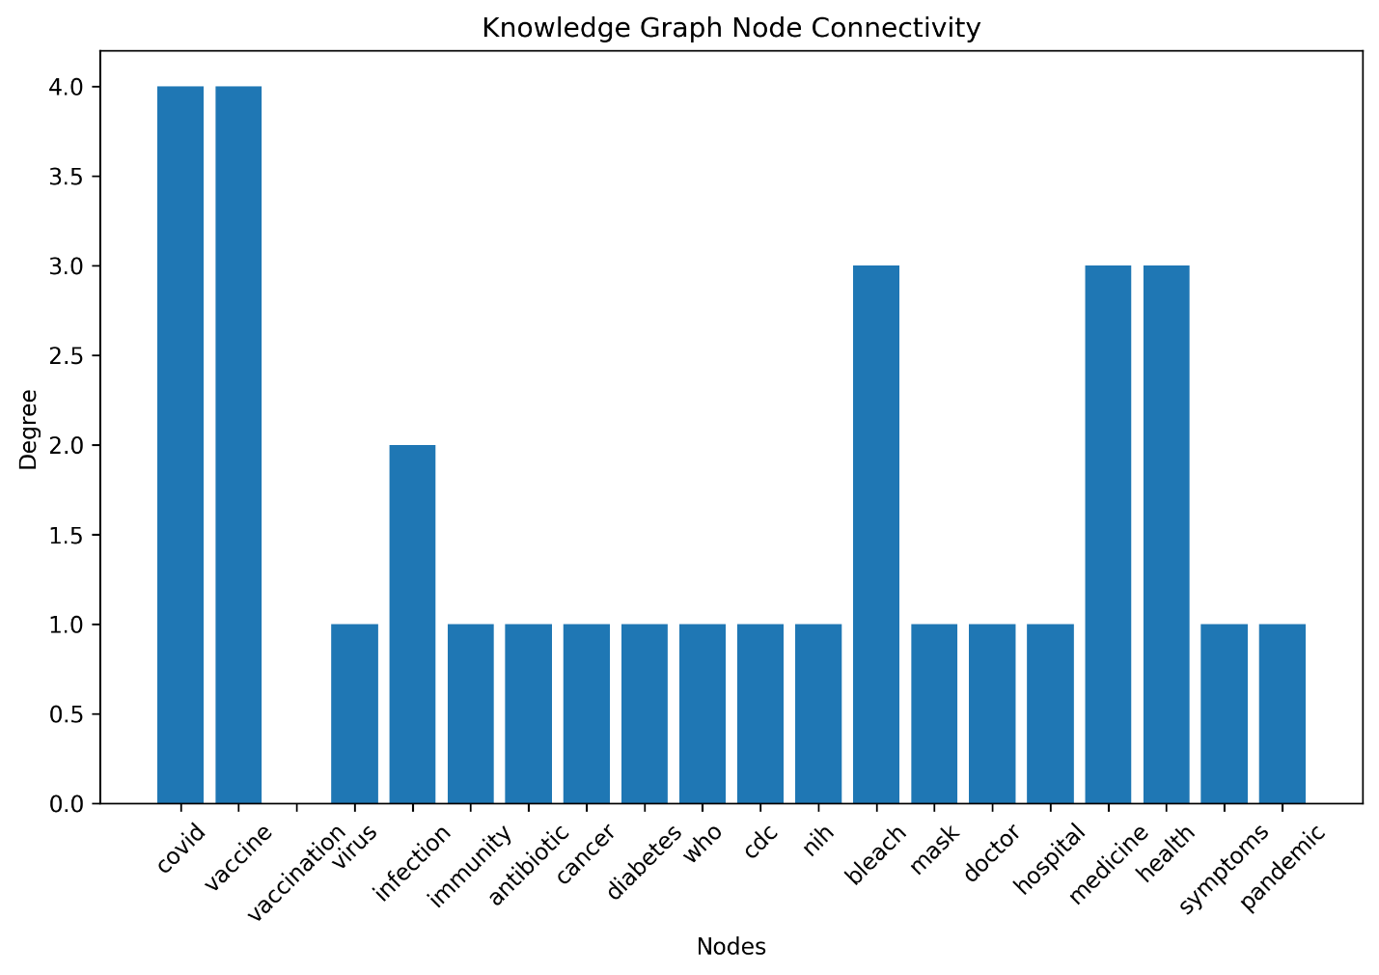
The “Knowledge Graph Node Connectivity” graph presents the degree connectivity of nodes within the constructed medical knowledge graph, illustrating how strongly each medical entity is semantically connected to other entities in the network. The graph shows that nodes such as “covid” and “vaccine” possess the highest connectivity degrees, indicating that these entities act as central hubs within the knowledge graph due to their multiple semantic relationships with healthcare organizations, symptoms, immunity, and pandemic-related concepts. Similarly, nodes such as “bleach,” “medicine,” and “health” exhibit relatively high connectivity because they interact with several supporting and contradicting relationships within the graph structure. Entities with lower connectivity degrees, including “who,” “cdc,” “nih,” “mask,” and “doctor,” maintain fewer direct semantic links but still contribute important contextual evidence during multi-hop retrieval. The variation in node degrees demonstrates that the graph structure effectively models real-world medical relationships, where some entities naturally serve as dominant semantic anchors for information propagation and reasoning. This connectivity distribution improves the efficiency of evidence retrieval and strengthens the explainability of the Graph-RAG verification framework.
- Medical Knowledge Graph Interpretation
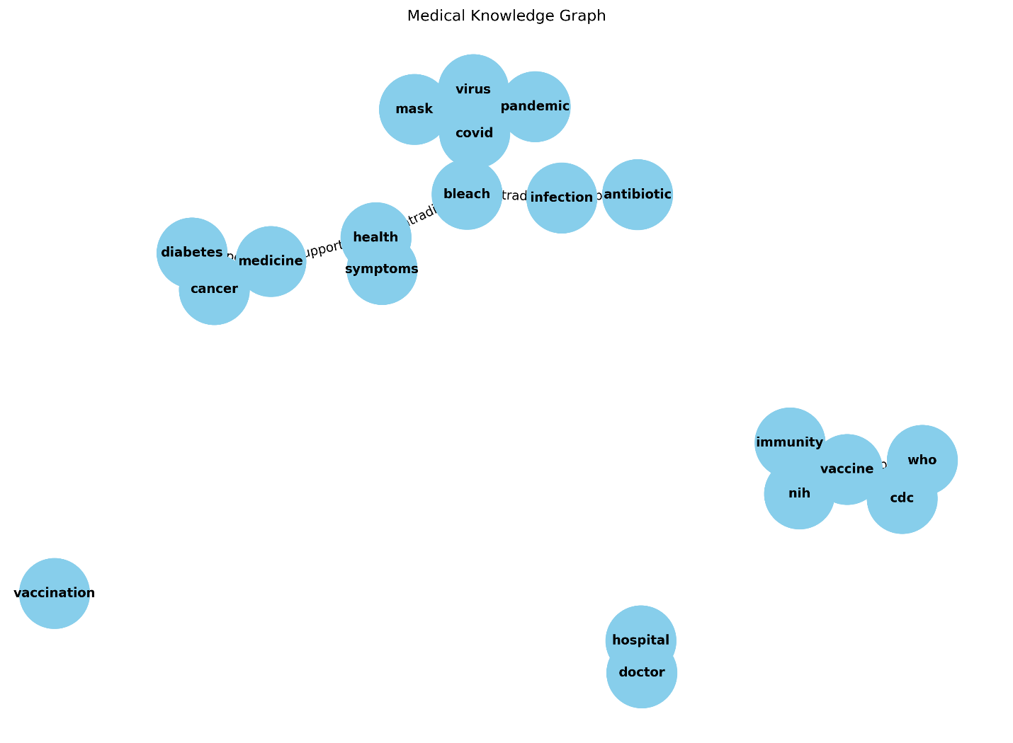
The first medical knowledge graph presents the foundational semantic structure of the Graph-RAG framework used for health fake news verification. The graph illustrates relationships among important healthcare entities such as covid, virus, pandemic, vaccine, health, and infection. The network structure shows that COVID-related entities occupy the most central positions within the graph, indicating that the dataset is strongly dominated by pandemic-related medical information and misinformation. The clustering of covid, virus, pandemic, and mask demonstrates the close semantic relationships among disease transmission, prevention measures, and pandemic discussions. Similarly, the vaccine cluster connecting vaccine, WHO, CDC, NIH, and immunity reflects the role of international health organizations and immunity-related concepts in supporting verified medical information. Contradictory concepts such as bleach are connected to health and infection nodes, indicating the representation of misinformation pathways within the graph. The presence of isolated nodes such as vaccination and smaller disconnected components such as doctor and hospital suggests that some entities have fewer semantic relationships in the dataset. Overall, the graph demonstrates the ability of the proposed knowledge graph framework to model healthcare semantics, support multi-hop reasoning, and capture both verified and misleading medical relationships.
Table 1: Analysis of Medical Knowledge Graph
Feature | Observation | Interpretation
Central Nodes | COVID, Virus, Vaccine | Core semantic anchors in fake news discussions
Vaccine Cluster | WHO, CDC, NIH, Immunity | Represents verified medical evidence sources
Contradictory Node | Bleach | Captures misinformation relationships
Graph Structure | Multiple connected clusters | Enables multi-hop evidence retrieval
Isolated Nodes | Vaccination | Indicates weak semantic linkage
Semantic Purpose | Support vs Contradiction | Improves explainability of Graph-RAG reasoning

- Professional Medical Knowledge Graph Interpretation
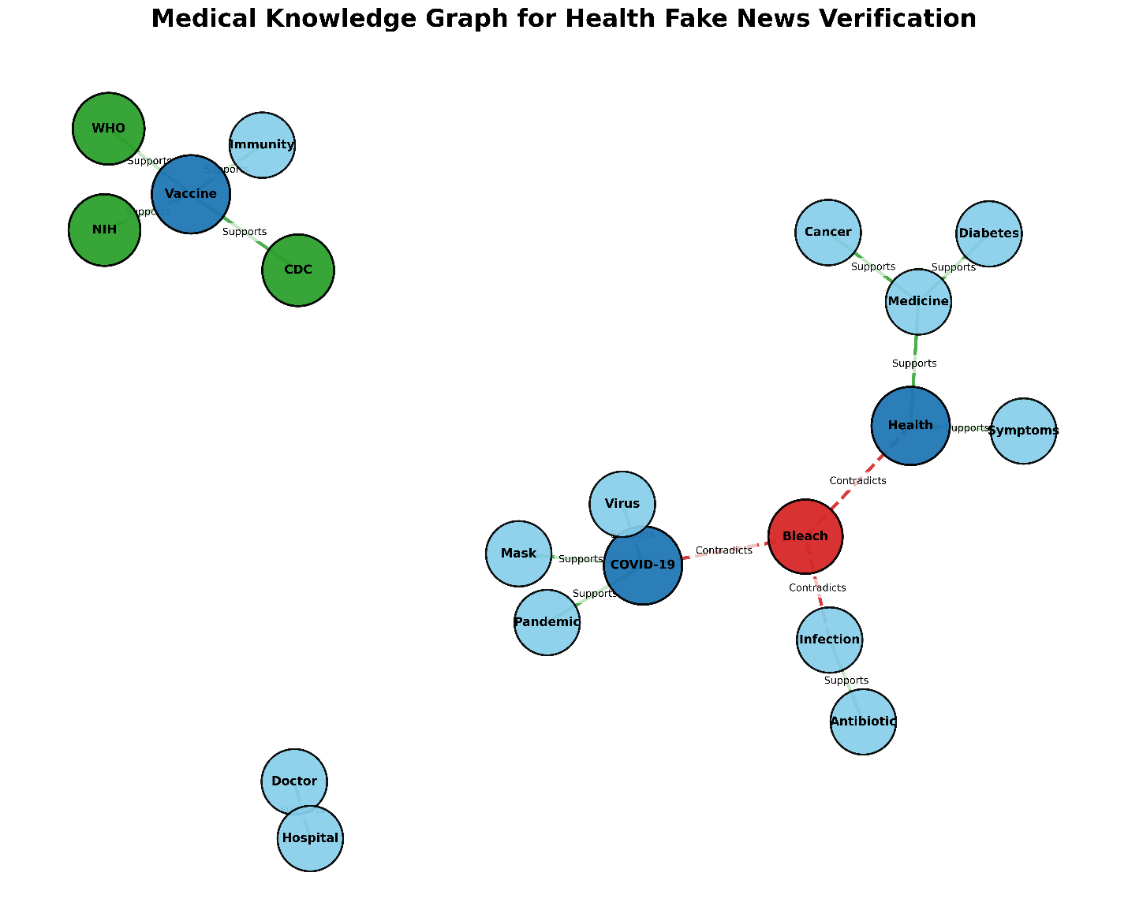
The professional medical knowledge graph provides an enhanced and more visually structured representation of the semantic relationships used in the Graph-RAG verification system. Compared to the previous graph, this visualization improves node grouping, edge differentiation, and semantic clarity. The graph clearly separates supportive relationships, represented by green edges, from contradictory relationships, represented by red dashed edges. The node COVID-19 acts as a major semantic hub connected to Virus, Pandemic, and Mask, emphasizing its dominant role in medical misinformation discussions. The Bleach node is visually highlighted in red, indicating its contradictory and misleading relationship with legitimate healthcare concepts such as Health and Infection. The vaccine verification cluster composed of Vaccine, WHO, CDC, NIH, and Immunity demonstrates a strong evidence-supported semantic community, showing how authoritative healthcare organizations contribute to factual verification. The graph also reveals secondary healthcare communities such as Medicine, Cancer, Diabetes, and Health, which collectively model disease treatment relationships. The improved layout and semantic grouping increase the interpretability and transparency of the Graph-RAG reasoning process, making the system more explainable for medical misinformation detection.
Table 2: Analysis of Professional Medical Knowledge Graph
Component | Observation | Significance
Green Edges | Support relationships | Represent verified medical evidence
Red Dashed Edges | Contradiction relationships | Represent misinformation pathways
Central Hub | COVID-19 | Dominant topic in health misinformation
Vaccine Cluster | WHO, CDC, NIH | Strong institutional validation
Red Highlighted Node | Bleach | Identifies harmful misinformation
Visual Structure | Well-separated semantic groups | Improves graph readability and reasoning
Semantic Communities | Medicine, Health, Infection | Supports multi-domain evidence retrieval

- True News Medical Knowledge Graph Interpretation
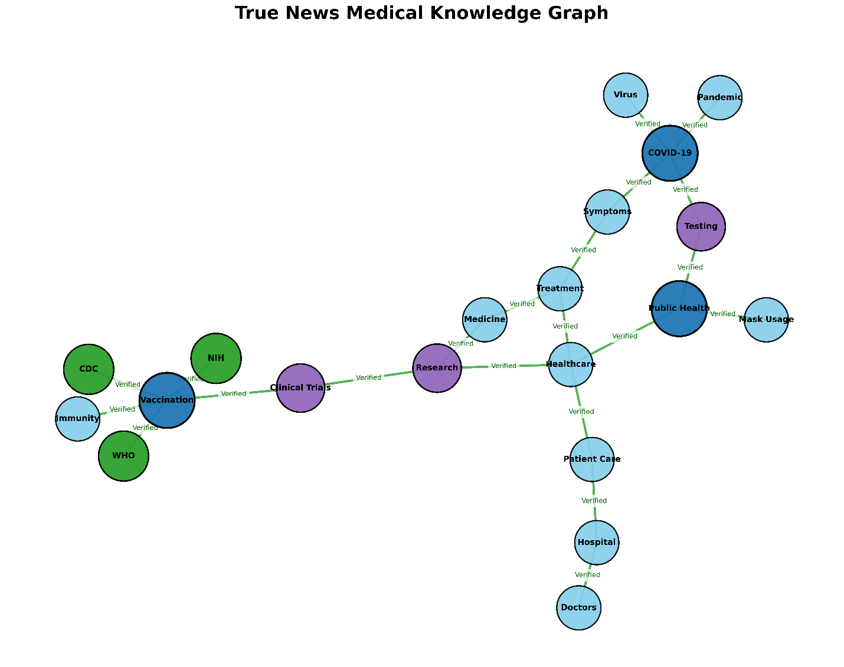
The true news medical knowledge graph models the semantic structure of verified healthcare information and factual medical relationships. Unlike the fake news-oriented graphs, this graph emphasizes validated healthcare pathways and institutional evidence chains. The graph demonstrates a continuous semantic flow beginning from Vaccination and healthcare organizations such as WHO, CDC, and NIH, extending toward Clinical Trials, Research, Healthcare, Treatment, and Patient Care. This structure reflects the real-world medical verification pipeline where scientific research, clinical validation, and healthcare institutions collectively contribute to trustworthy medical information dissemination. The node COVID-19 remains an important semantic hub connected to Virus, Pandemic, Symptoms, and Testing, demonstrating the central role of pandemic-related healthcare discussions even in verified medical news. The green verified edges throughout the graph indicate strong factual relationships and reliable evidence propagation between entities. Additionally, the integration of healthcare delivery concepts such as Hospital, Doctors, and Patient Care illustrates the practical medical implementation of verified healthcare knowledge. Overall, the graph demonstrates how structured knowledge graphs can effectively represent trustworthy healthcare ecosystems and improve explainable evidence retrieval for true medical news verification.

Table 3: Analysis of True News Medical Knowledge Graph
Component | Observation | Interpretation
Verified Edges | Green semantic links | Represent factual medical relationships
Institutional Cluster | WHO, CDC, NIH | Trusted healthcare authorities
Research Pipeline | Clinical Trials → Research → Healthcare | Models scientific validation workflow
COVID-19 Cluster | Virus, Pandemic, Testing | Captures pandemic-related healthcare evidence
Healthcare Delivery | Hospital, Doctors, Patient Care | Represents real-world medical practice
Knowledge Flow | Continuous connected structure | Indicates strong semantic consistency
Graph Purpose | True medical information modeling | Supports reliable evidence-based verification

